Mr. Henry,

This week I tried to turn my focus onto my next form of testing, Automated UI Testing however I ran into some problems. In order to run these tests I realized that I needed my site up on the web so that I could simulate logging into the site and due to the way the UI Automated tests work I need to pull up the address of the site and it will not work running locally. Also, as part of my project I wanted to be able to have my site up and working so that I could point you towards a working model of my work…...but I’m finding that publishing an ASP.NET site is easier said then done.

I have worked all weekend, trying to get my my site up and I am still not having any luck, I’ve dealt with everything from time our errors:

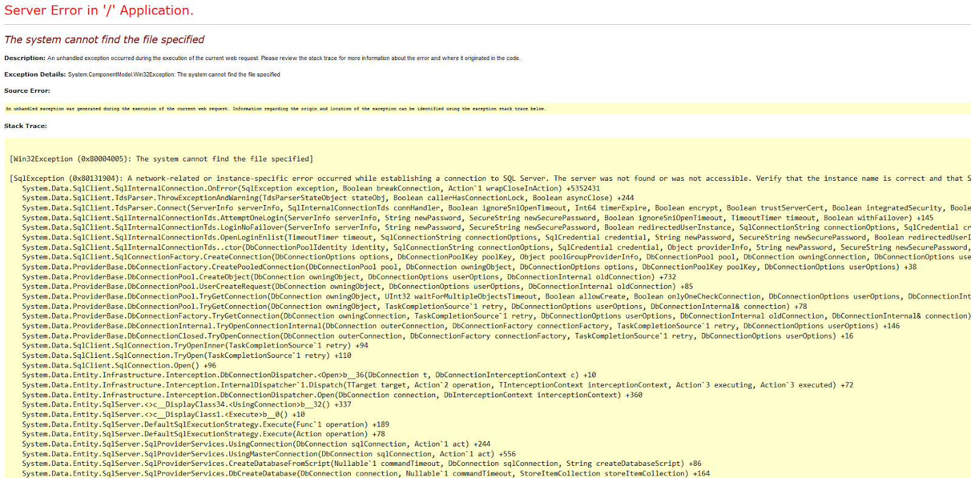

To connection strings, to web.config and I am just stumped. I believe that its due to my web.config trying to refrence my localDB, but my host only gives me 1 database for free and I am having a really hard time finding help.

I’ve posted looking for questions on stack overflow:

<http://stackoverflow.com/questions/26986089/asp-net-web-form-not-working-after-publish-works-locally?noredirect=1#comment42505529_26986089>

and have worked with my menor at Orbital Shift and and Web.config is winning.

Do you have any suggestions on where to look for help.

Here is my address:

<http://jesseshockeyshop.somee.com>

Its currently not working and I’m getting to a point where I don’t know what else to do.

I will continue to fight with it this week but I may need to try and tackle something else or see what I can change in my site to get it to work.

-----------

Did you ever hear back from Rob Smith about presenting to his class? And if so what day and time should I be looking for.

Thanks again for your help,

Jesse Fulcher